Driver’s License or State ID Verification

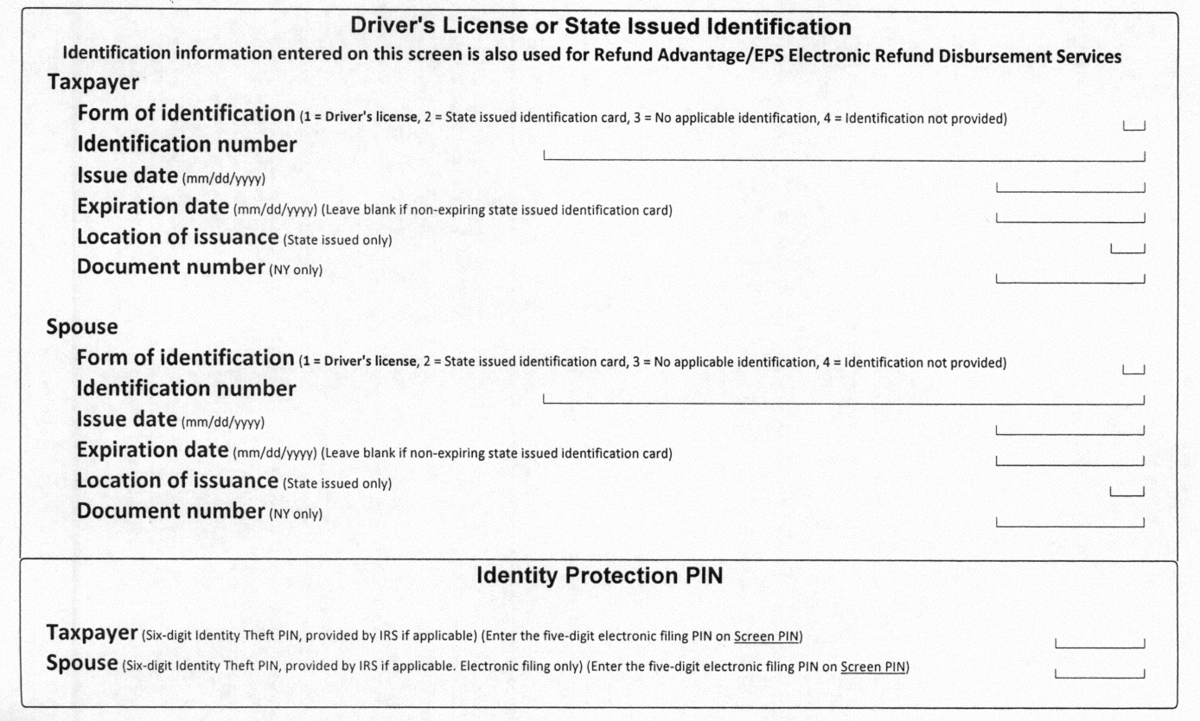

***FYI: The document number is located either on the front in the bottom-right corner, or on the back on the right side.***

This information is an added security measure to prevent Identity Theft of your tax return information.

An individual return cannot be filed electronically in many states, including New York State and California if you do not provide this information.

